Computer Network Lab 07

Name: Ahmed Kasteer

Roll Number: 20F-0336

Section: 5C

Static

Router 1

Router 2



Router 3

Command Prompt

Router 1 NAT translation

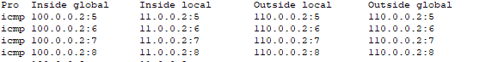

Dynamic

Router 1

Router 3

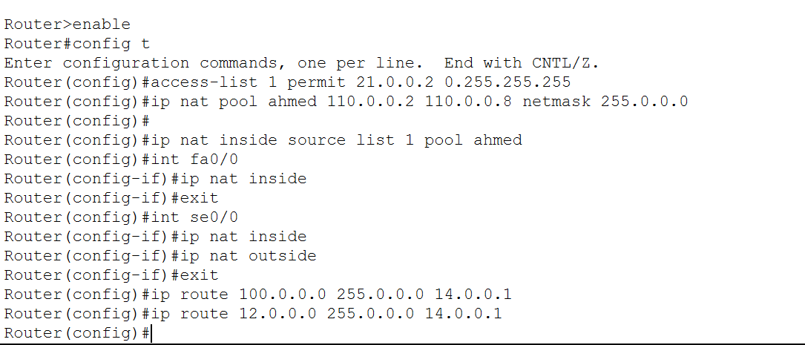

Command Prompt

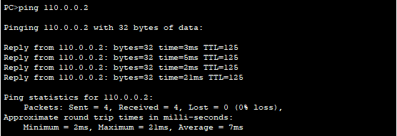

PAT

Router 1

Router 3

Command Prompt

